Practical Week 11
- Develop a multithreaded counter application using POSIX threads (pthread_create, pthread_join). Demonstrate race conditions by allowing multiple threads to update a shared variable concurrently.
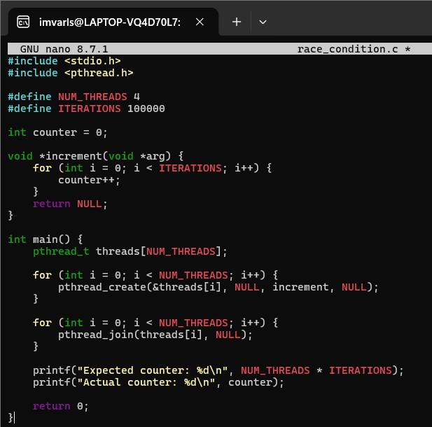
Output:
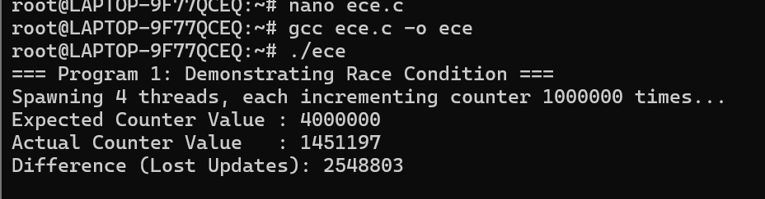

- Modify the previous program using mutex locks (pthread_mutex_lock, pthread_mutex_unlock) and compare the outputs with the race-condition version. Analyze the impact of synchronization.
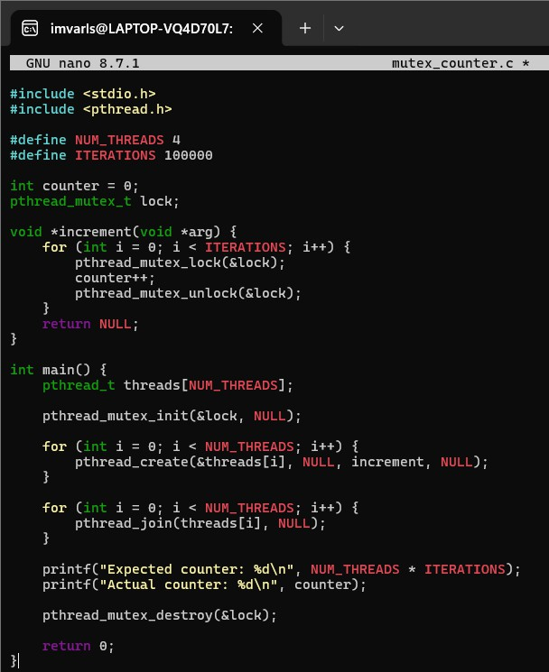
Output:
